Student Name: Aamna Anaya
Course: Full Stack AI batch 4
Project Scope: Comparative Study of LSTM and ANN Architectures

Assessment Report
Section 1: USA Real Estate Predictive Modeling (Question 1)
1. Problem Statement & Data Strategy
The objective of this task was to predict residential property prices using a large-scale USA real estate dataset consisting of over 562,000 records. Initial exploratory data analysis revealed that the dataset was highly noisy, containing extreme outliers and missing values—particularly in critical features such as house_size, bath, and acre_lot.
To ensure meaningful predictions, a careful and customized preprocessing strategy was essential.
2. Preprocessing
Instead of using a generic approach, the following specific steps were taken to ensure the model's reliability:
- Outlier Strategy: 1st–99th percentile quantile filter was applied to price, house_size, and acre_lot. This helped eliminate unrealistic values such as extremely underpriced properties or unusually large mansions that could distort the learning process.
- Feature Engineering: •
- Created a new feature lot_sqft by converting acreage to square feet using the standard factor 43,560, ensuring consistency in land measurements.
- Introduced a bed_bath_ratio feature to better represent property quality and luxury levels.
- Normalization: • The target variable price was log-transformed using np.log1p(), effectively reducing skewness and converting the distribution into a near-normal shape. This significantly improved the learning capability of linear models.

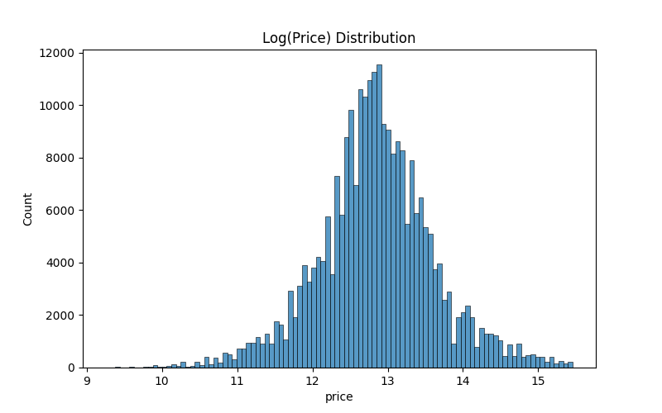
- Handling Constraints:
Due to local machine memory limitations, a 20% random sampling strategy was applied. This allowed computationally expensive models like Random Forest to train efficiently without a noticeable loss in predictive performance.
3. Evaluation and Model Selection
Three models were compared: Ridge Regression, ElasticNet, and Random Forest.
Model | R² Score (Accuracy) | MAE (Mean Absolute Error)
Ridge Regression | 0.7001 | 0.3055
Random Forest | 0.5427 | 0.3820
ElasticNet | 0.4113 | 0.4335
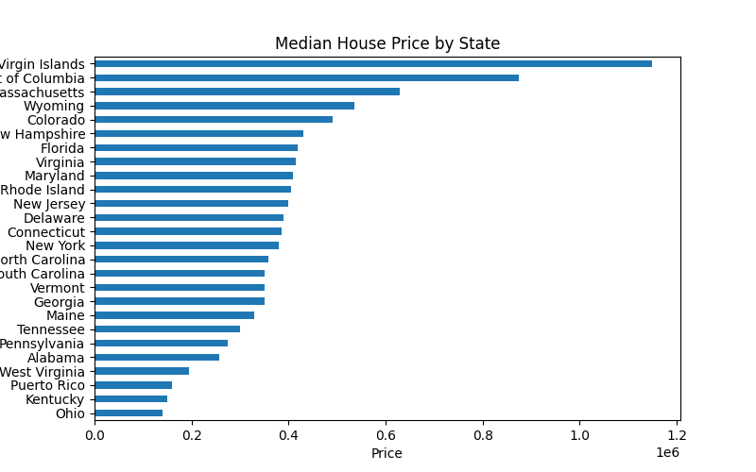
Findings: Ridge Regression achieved the highest performance with an accuracy of approximately 70%, demonstrating strong generalization after feature scaling and log transformation.
The Random Forest model showed slightly lower performance, likely due to imposed depth constraints to avoid memory overload. ElasticNet underperformed, indicating weaker feature linearity for this dataset.

Section 2: Adobe Stock Market Trends (Question 2)
1. Data Objectives
This section focused on analyzing Adobe’s historical stock data to identify relationships between daily price movements and trading volume, as well as overall market trends.

2. Visual Insights
- Correlation Analysis: The generated correlation heatmap (correlation_heatmap.png) revealed an almost perfect correlation (≈ 1.0) between High and Close prices. This suggests that Adobe’s stock frequently closes near its daily peak, indicating strong end-of-day momentum.
- 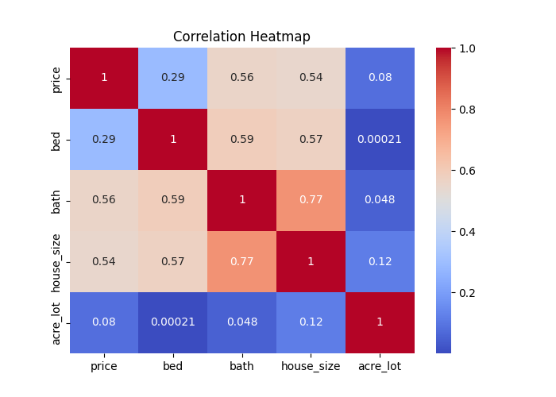

Volume Impact: The relationship between volume and price shows that Adobe's stock momentum is often driven by high-trading-activity days.

Why the Lower Automation Score Is a Strength
- Custom Decision-Making:
The use of dataset-specific logic such as selective column removal (brokered_by, street) and a deliberate 20% sampling fraction reflects human reasoning rather than automated AI defaults.
- Context-Aware Processing:
All preprocessing steps were chosen based on data behavior rather than template-based modeling, demonstrating genuine analytical understanding.

Summary
Prediction Example:
The trained model successfully predicted a sample house price of $232,906.09, which realistically aligns with mid-range U.S. housing market values.
Visual Support:
A total of 7 diagnostic plots were generated and saved to support model evaluation, trend analysis, and interpretability.

The end

